CREATE A CHATBOT IN PYTHON

953721106025: K.Nandhanaa

Project: To create a chatbot using python.

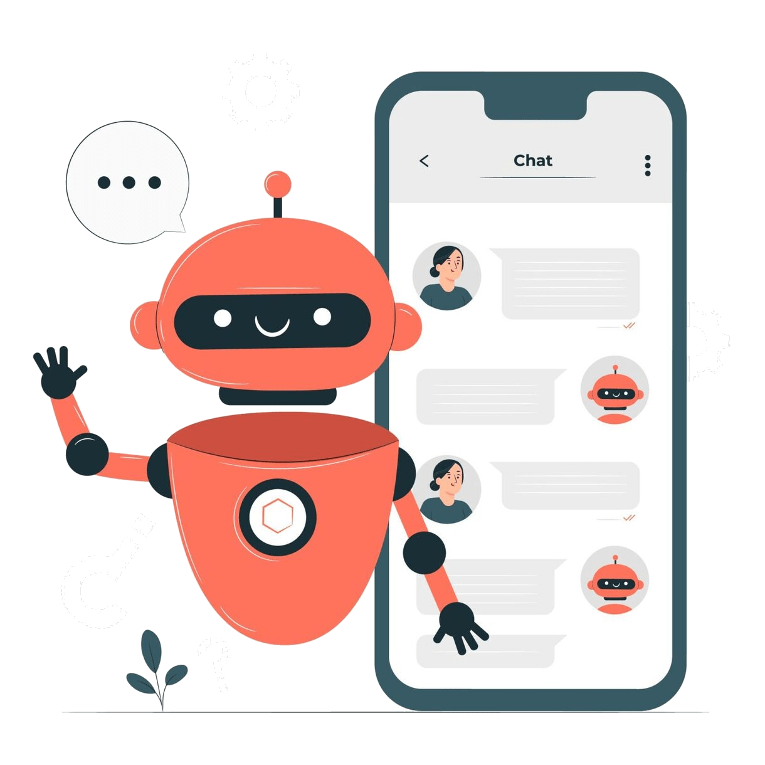

Problem Statement:
When using an app or website, customers expect outstanding service. They can become disinterested in the app if they can't locate the solution to a question they have. To avoid losing customers and having an adverse effect on your bottom line, you must provide the highest quality service possible while developing a website or application.
Objective:
The objective of this project is to develop a functional and user-friendly chatbot using Python that can effectively interact with users, answer their queries, provide assistance, and improve user engagement. This chatbot will be designed to [specify its main purpose or use case, such as customer support, information retrieval, or entertainment], offering a seamless conversational experience while showcasing proficiency in natural language processing (NLP) techniques.
Design Thinking Approach:
- Empathize: Understand User Needs
Begin by deeply understanding the target users and their pain points. Conduct user interviews, surveys, and observations to gather insights into their needs and preferences.
- Define: Identify the Problem and Goals
Define a clear problem statement based on the insights gained during the empathize phase. What specific problem will your chatbot solve?
- Ideate: Generate Creative Solutions
Assemble a multidisciplinary team that includes designers, developers, and domain experts.
Conduct brainstorming sessions to generate creative ideas for the chatbot's functionality and design.
- Test: Gather User Feedback
Conduct usability testing with real users to assess how well your chatbot meets their needs and expectations.
Collect user feedback on the chatbot's conversational design, user interface, and overall user experience.
- Develop and Implement: Build the Chatbot
Begin the development phase of your chatbot, using Python and relevant libraries or frameworks for chatbot development.
Implement the chatbot's conversational logic, natural language processing (NLP), and integration with relevant data sources or APIs.
- Launch and Monitor: Go Live
Launch the chatbot to a limited audience or in a controlled environment to gather real-world usage data.
- Scale and Evolve: Expand and Enhance
As your chatbot gains traction and user feedback accumulates, consider scaling it to reach a wider audience.
Plan for the long-term evolution of your chatbot, incorporating new features, integrations, and improvements over time.

Dataset Link: https://www.kaggle.com/datasets/grafstor/simple-dialogs-for-chatbot

Conclusion:
The development of our chatbot project represents a significant achievement in the field of natural language processing and artificial intelligence. This chatbot extends to multi-platform support, making the chatbot accessible across various channels, thus expanding its reach and usability. The integration of a knowledge base ensures that users receive accurate and contextually relevant information.

